Name **Nuzhat Qureshi**

Roll No BIT-24S-029

Github link [NuzhatQureshi90/Pythons-lab-manual-IT-A-: Python lab manuals](https://github.com/NuzhatQureshi90/Pythons-lab-manual-IT-A-)

**LAB MANUAL 2:**

**TASK 1:**

Q.1 Print numbers from 1 to 10 using a for loop.

Program:

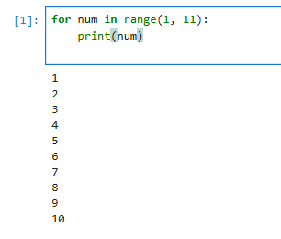

**Task 2:**

Q.2. Print all even numbers between 1 and 20 using a while loop.

Program:

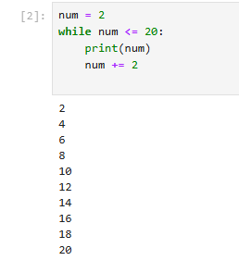

**TASK 3:**

Q.1. Calculate the sum of numbers from 1 to 100 using a loop.

Program:

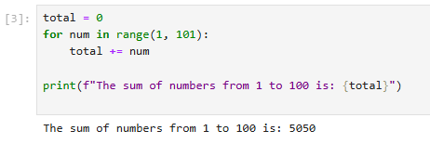

**TASK 4:**

Q.1. Print the multiplication table of 5 using a loop.

Program:

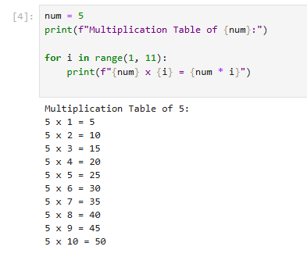

**TASK 5:**

Q.1. Find the factorial of a given number using a for loop.

Program:

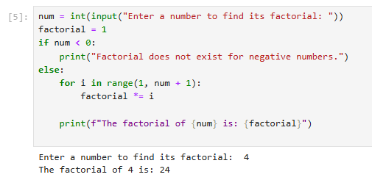

**TASK 6:**

Q.1. Create a list of numbers and print only the odd numbers using a loop.

Program:

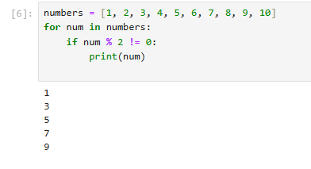

**TASK 7:**

Q.1. Iterate over a list of fruits and print each item.

Program:

